JJQ-P3116
Fully Automated Rotary Microtome

Instructions manual

Attention: Before using the machine, please read this Instruction carefully, and keep the Instruction for further reference.

WUHAN JUNJIE ELECTRONICS CO., LTD

Address：Chuangye Street 10-A-404, Guanggu, East Lake High-tech Development Zone, Wuhan City
Postcode：430074
Tel: 8627-87401756 / 862787411993 Fax:8627-87411993
Website：http://www.whjjbl.com E-mail： junjiedianzi@126.com
Biosystems RM2265 Fully Automated Rotary Microtome

Contents
1.Caution and Attention…………………………………………………………2
2、Instrument safety……………………………………………………………2
2.1 Safty installation…………………………………………………2
2.2.The lock system of the handwheel………………………………3
2.3. Knife protector on knife holder…………………………………………3
2.4 Transportation & Installation……………………………………3
2.5 Operation ……………………………………………………………3
2.6 Cleaning………………………………………………………………4
2.7 Maintenance and attentions…………………………………………………4
3、Technical………………………………………………………………………4
4、Brief……………………………………………………………………………5
4.1 Instrument structure………………………………………………………5
5、Opening box and the placement of the instrument……………………5
5.1 Opening box……………………………………………………………5
5.2 Requirement of the instrument placement………………………6
6.Installation……………………………………………………………………6
6.1 Specimen clamp framwork……………………………………………6
6.2 Standard Specimen Clamp……………………………………………6
6.3 Currency Specimen Clamp……………………………………………6
6.4.The change of Specimen Clamp………………………………………7
6.5 Installation of disposable knife…………………………………7
6.6 Installation of kinfe holder………………………………………7
6.7 Disassembly of knife holder………………………………………8
7、Instrument Operation…………………………………………………………8
7.1 Triming…………………………………………………………………8
7.2 Cutting ………………………………………………………………8
8、Fault diagnostics and elimination…………………………………………………9
9、Cleaning………………………………………………………………………11
10、Maintenance……………………………………………………………………11
1.、Caution and Attention
  - Please read the user manual carefully and shall comprehend each issue of technical specification and function of instrument before the operation. The operation method must comply with the instruction.
  - If the instruction, drawing and the techicial in this manual has the conflict with the ;law in the user’s country,we don’t take on this responsiable. In particularly,(Among other areas) because of the application as described in this manual, which bring the damage, we also don’t take on this responsiable.
  - The instruction, drawing ,the techicial and other information in this manual not show that the factory warranty the feature of the instrument, only the matter agreed in the contract has the legal effect..
  - Cleap up the instrument frequently and add lubrication regulat.
  - Please check and maintain the protection setting termly accordingly to the request in the manual

2、Instrument safety
2.1 Instrument safety
● Before power on the instrument, confirm the earthing line must be firmly grounded that comply with GB9706.1-1995 standard. When doing the microtomy, be careful the cutting knife which is very sharp. The wrong method of operation might cause to serious injured, and never pick up the dropping knife by hand.
●This instrument is working separately and don’t touch its electric wire when the instrument is switching on.
- The instrument shall be away from electromagnetic interference.
- Lubricate all the motion parts every 3 months, the parts such as slideway of knife carriage.
- Checking method: Check if there is any loosening for all the fastening screws, circuit board and socket connector, check if the earthing wire is grounded well.
Notice: Lock up the handwheel before its cleaning
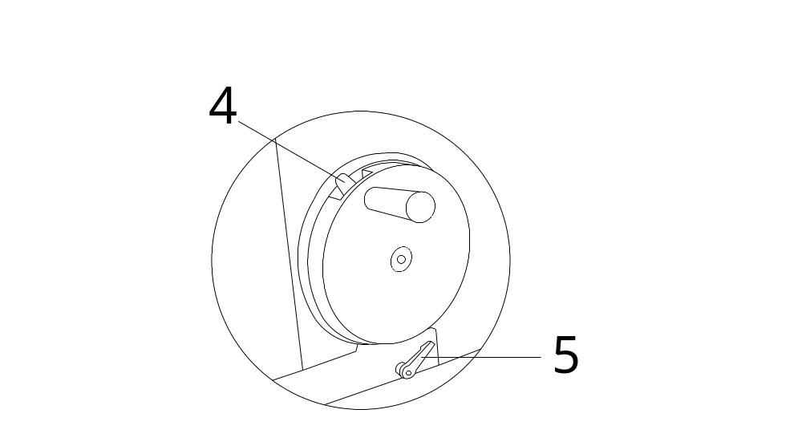
2.2 Locking the handwheel
Attention: Lock up the handwheel before operate the knife and change the specimen.
●.On the top of the handwheel,there are a lock lever(4), use the locking lever (4)to lock the handwheel at any position. Push the lock lever in clockwise will lock the handwheel, and push the lock lever in counter-clockwise will loose the handwheel.
- In the below of the handwheel, there are another lock lever(5),it can lock the handwheel completely, this is lever is usually used in the transport or finished the operation of the instrument.
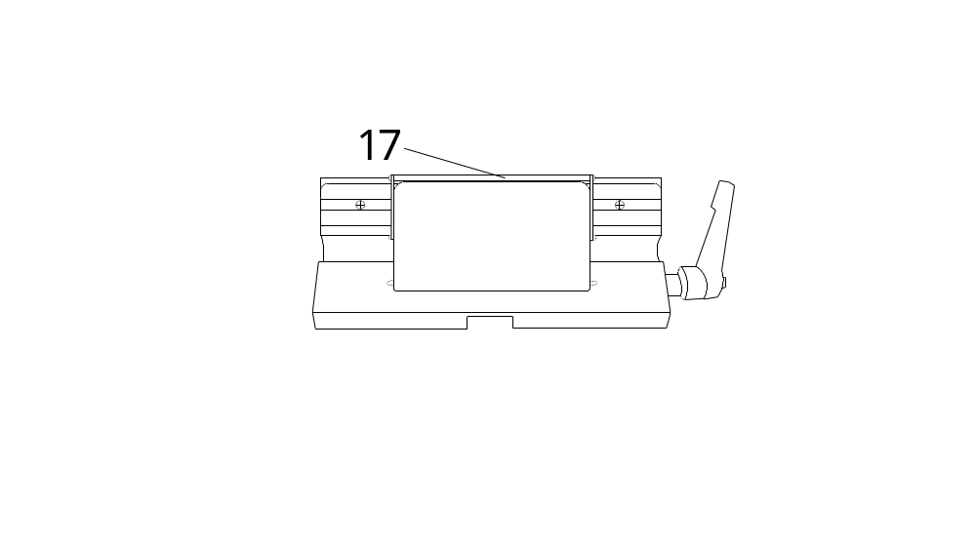
2.3. Knife protector on knife holder
Attention: when doing the microtomy, and changing the specimen and taking a short break during processing the microtomy, please must lock the handwheel and cover the edge of knife with protector lever!
There are moveable knife protector in every knife knife holder(17), which can protect the user durning the operation.
2.4 Transportation & Installation
- The instrument can only be placed and transported face up.
- Durning the transport, not allowed to grasp the handwheel.
- Not allowed to disassembly and change the protector in the instrument.
2.5 Operation
- Please be careful on fitting the disposable blade, its edge is very sharp. The mis-operation might cause to serious injured.
- Do not litter the disposable blade and knife carriage on the floor! The unused disposable blade should be kept in its packing box.
- Please clamping the specimen, and then fit on the disposable blade on the knife carriage!
- Preventing any liquid flow into instrument while doing the microtomy!
2.6 Cleaning
● Note: Please lock-up the handwheel before cleaning
●Brush off the section scraps with a dry brush.
●Dismantling the knife carriage and its base for cleaning.
Notice: 1) it only can use soft and normal cleanser or soap liquid to clean the instrument!
2) The painting surface of housing cannot resist and bear any acet. and benzene!
3) It is forbidding for any liquid flow into the instrument while cleaning.
2.7 Maintenance and attentions
●The instrument should be cleaning up daily.
●Please do not repair the instrument roughly, otherwise, the commitment of warranty will be ruined. The instrument can only be repaired by the technician authorized by our company

3、Technical：
JJQ-P3116 Semi-actumatic microtome
1、Range of the thickness of slice: 0.25-100（μm）
2、Range of the thickness f triming:Any.
3、Minimun setting thickness of slice: 0.25（μm）
4、Setting thickness of slice range：
0.25-1（μm） increment: 0.25（μm）
1-5（μm） increment:0.5（μm）
5-10（μm） increment:1（μm）
10-20（μm） increment:2（μm）
20-100（μm） increment:5（μm）
5、Precise error:±10%
6、Specimen retraction: 20μm
7: Specimen horizontal feeding: 26mm
8、Stroke length: 70mm
9、 Maximum section size: 35*40(mm)
10、Electric supply: AC220V/50Hz
11、Power: 100VA
12、Unit demension: 530*460*310(mm)
4、Brief
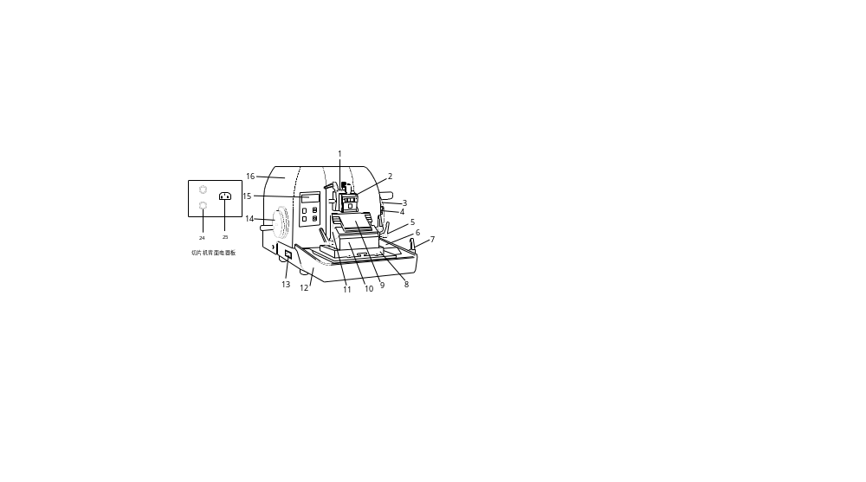
4.1 Instrument structure

1.Specimen clamp system 2.specimen clamp 3.Big handwheel 4.Lock lever of big handwheel 5.Lock wrench 6. Base plate 7.Lock lever 8.Knife holder plate 9. Press plate 10.Movable knife holder 11.Knife holder 12.Rubbish holder 13.Power switch 14.Fast forward and backward handwheel 15.Panel 16.shell 24.fuse 25. electrical outlet

5、Opening box and the placement of the instrument
5.1 Opening box
- Opeaing the outside wood box. 。
- Take out all of the accessories and the operation manual.
- Take out the instrument from the box.
Attention：Don’t grasp the handwheel durning carry the instrument.
5.2 Requirement of the instrument placement
- The instrument should be placed in a steady platform of the laboratory
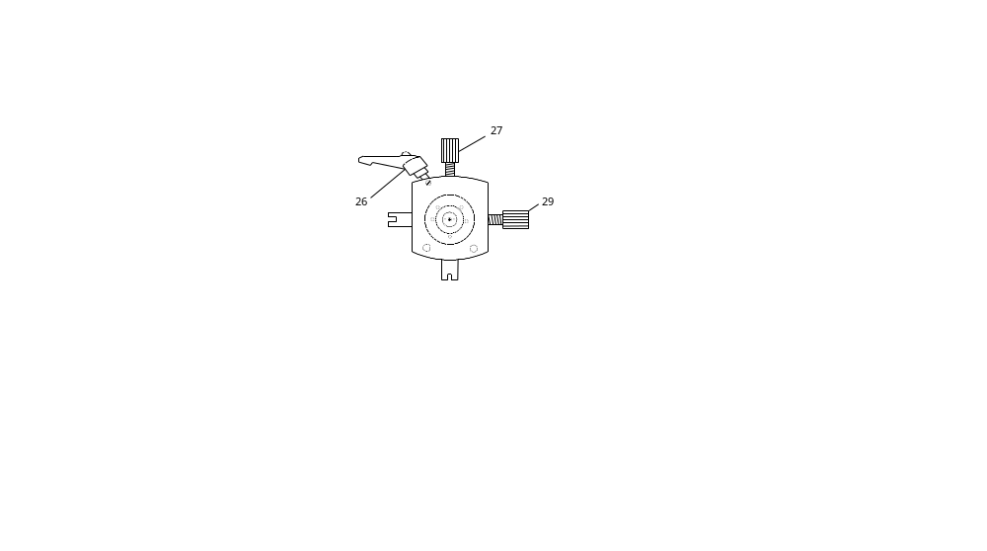
- The plateform should be steady and no vibration.
- The ground should be no vibration.
6、Installation
6.1 Specimen clamp framwork(see the drawing of the framwork.）
The adjusted specimen clamp framwork has be installed into the instrument, if the instrument haven’t installed the specimen clamp framwork, please install it first and adjust it.
（27）The Vertical adjust knob of the spacimen clamp.
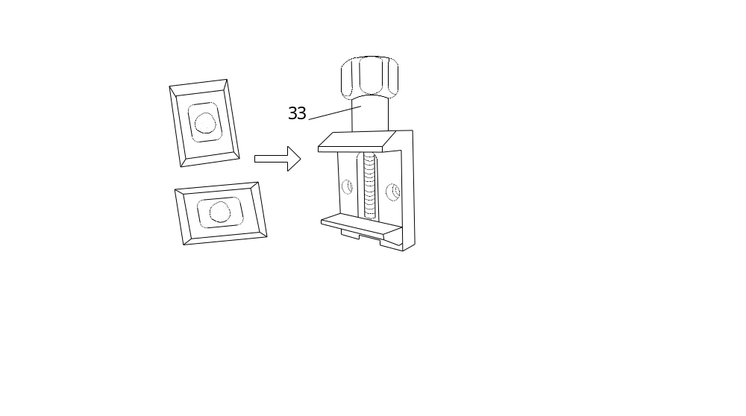
（29）The horizontal adjust knob of the spacimen clamp.
（26）The lock lever of the specimen clamp.
6.2 Standard Specimen Clamp
- Through rotate the big handwheel, adjust the speciment clamp into the highest point, and then lock the handwheel.
- The adjustment of the standard specimen clamp:lossen the lock lever(26),adjust the specimen Vertical and horizontal position through adjust the adjust knob(27).(29)
6.3 Currency Specimen Clamp
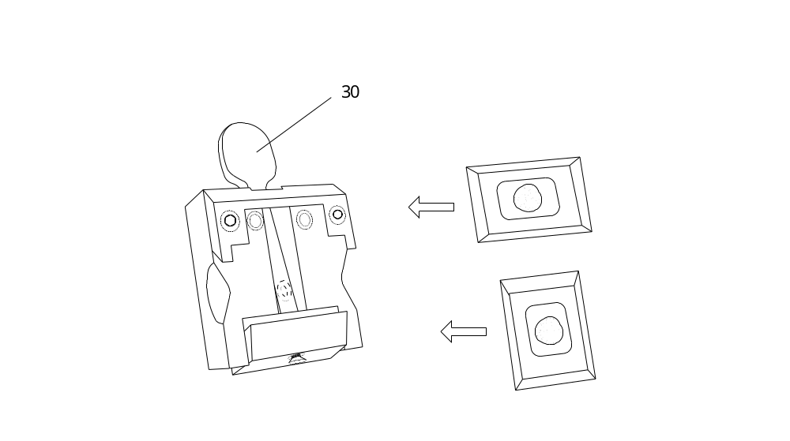
- Through rotate the big handwheel, adjust the speciment clamp into the highest point, and then lock the handwheel.
- The mothed of the adjustment of the specimen clamp is the same as the Standard Specimen Clamp
- The fix of the specimen clamp(wax):Push the wrench(30),then put into the the specimen clamp(wax) in Vertical or horizontal, then lossen the wrench(30),the specimen clamp(wax) is fixed .

6.4 The change of Specimen Clamp
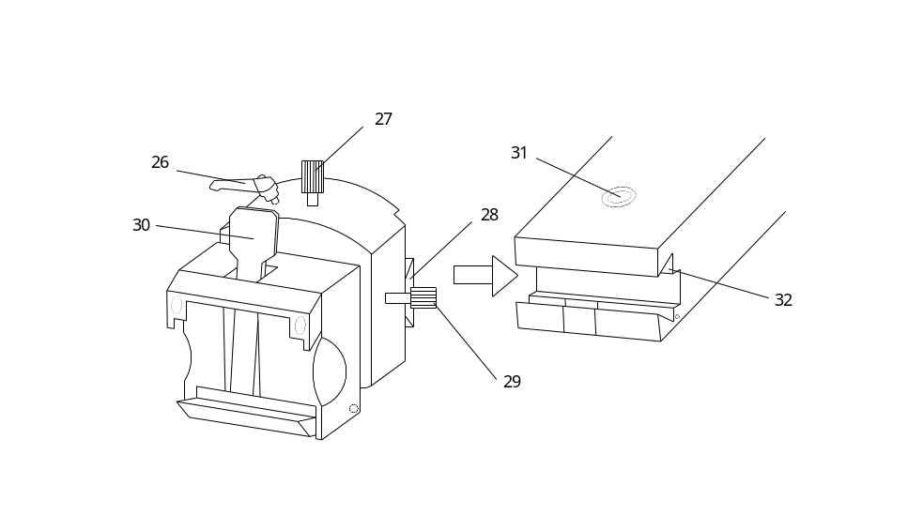
- Lossen the hex head screw when change the specimen clamp.Take out the dovetail seat (28)from dovetail groove(32), then instert the changed specimen into dovetail groove(32),finally lock the hex head screw(31).
6.5 Installation of disposable knife
Attention:Don’t insert the disposable knife if the knife holder is not installed in the instrument! To be safe, plese take off the disposable knife before change or install the knife holder.
- Turn the locking lever (18) anticlockwise, and now the press plate is lossen, the press plate can be move in left and right side, adjust the position of the press plate, then insert the disposable knife in any side of the press plate, put it steady in horizontal, then Turn the locking lever (18) clockwise , so the knife is installed.
- 6.6 Installation of kinfe holder
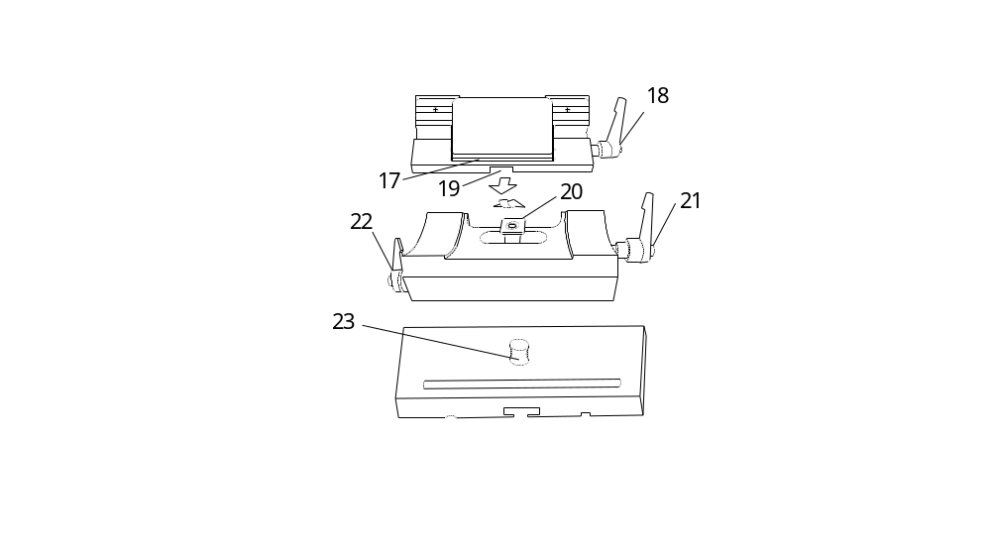
- Turn the locking lever (18) anticlockwise，put the slot i(19 )into the knife holder slot (20), after put the knife holder in steady, Turn the locking lever (21) clockwise, then the knife holder is installed.
- Adjust the angle of the knife holder: lossen the lock lever (21),after adjusting the angle of the knife holder, then lock the lever(21). In the right side , there are the angle adjust scale, which will help the user to find the knife angle easily.
- Take out the locking lever(22), put the movable knife holder(10) into the locking holder(23), then insert the locking lever(22),and lock it.
- Insert the knife holder Bottom-Board(8) into the T model block, then lock the lock lever(7).
6.7 Disassembly of knife holder
- When disassembling the knife holder, lossen the lock lever(22) first, then draw out the lever, the knife holder can be take off from the instrument..
7、Instrument Operation
Firstly, switch on the power supply(the power socket is in the back of the instrument),in the mean time, lossen the lock lever(5).
7.1Triming
- Lossen the lock lever(7),push forward of the knife holder, let the knife colsed to the specimen, then lock the lock lever(7), fix the knife holder.
- Lossen the specimen clamp lock lever(26),adjust the horizontal knob(29) and vertical knob(27) separately.
- After finishing the triming, the serface of the specimen should be smooth. Then lossen the big handwheel lock lever(4), turn on the big handwheel (3)clockwise, let the specimen clamp in the highest position, and lock the big handwheel, now the specimen is waiting for operating.
7.2 Cutting
- See the operation panel(15), firstly. Press the “set” botton, the screen will show(set the thickness ),then press the advance botton “△”, or backforward botton“▽”,set the cut thickness(3μm or 5μm ), then press the “enter” botton. Now in the screen show the thickness number of the cutting, then lossen the lock lever(4),turn on the big handwheel(3) to cut the specimen. If the big handwheel is turning in continuously and uniformly, so the specimen is cut in continuously and uniformly also.
- The big handwheel finish turning one circle, that’s to say cut once. The best mothed way to cus is turn the handwheel clockwise, from the start position switch back to the primary start position uniformity(one circle), if turn the handwheel too fast, the specimen will be compressed, resulting in the phenomenon of mutual viscosity.
- Attention: Turn the handwheel uniformity,and the rotational speed must be compatible with the hardness of specimen,when cut the hard specimen, the speed should be much slower.
As for many times cut, the horizontal position moved into the extreme position, when the instrument send out the alarm sound, you should stop to cut, then press the botton“▽” in the panel(15) to backward, till send out the alarm sound, then turn the small handwheel(14),or press the fast forward botton“△” to cancel the alarm sound.
7.3 Finished cutting
- Turn the handwheel and let the specimen clamp in the highest position, then lock the handwheel.
- Take off the knife from the knife holder, put the knife into the knife box.
- Bckward the knife holder into the original postion, take off the specimen from the specimen clamp.
- Clean the scrap in the instrument, then take off the Rubbish holder(12), and dump the rubbish.
- When not use the instrument, use the plastic cover to cover the instrument,make sure clean.

8、Possibly fault, cause and elimination
Fault | Cause | Elimination
The sectioning thickness is unevenly.  Sectioning thickness variety, and even sometimes it cannot get a section after the microtomy process | 1. The tilting angle of the cutting blade is not appropriate, that is the rear angle is too small. | Adjust the rear angle bigger. Test the cutting by gradually increasing the rear angle until to an appropriate rear angle.
 | The specimen clamp or the tightening screws of the blade holder are not securely locked.  The slicing blade is too blunt. | Check the specimen clamping system and all the screws of blade holder to see if they are tightened or not. Shift to the other spot of blade edge for cutting. or replace with the new blade. Gradually reduce the rear angle to test the cutting until to an appropriate rear angle.
The section is compressed. | The blade is blunt. | Shift to the other spot of blade edge for cutting.
The section is seriously compressed | The specimen is too hot. | Freeze the specimen for several minutes
the section is wrinkled with each other. | The rear angle of the cutting blade is too big. | experiment the sectioning by gradually reducing the rear angle until up to an appropriate rear angle.
the section is extruded with each other. | The sectioning speed is too fast. | rotate the hand wheel more slowly.
The cutting blade squeaks while cutting hard specimen. | 1、The sectioning speed is too fast  2、The rear angle is too big. | 1、rotate the hand wheel more slowly.  2、experiment the sectioning by gradually reducing the rear angle until up to an appropriate rear angle.  。
The panel does not work. | The film switch of panel is not in the good condition. | Replace the film switch of panel.
No feeding on specimen clamp and of course it cannot be sectioning. | The specimen clamp has reached its frontier end position | Turn the small handwheel and backward the specimen.
The display is not light up after switch on power. | 1.The power cable was not well connected.  2. The fuse is burnt. | 1. check the power cable is inserted to socket properly.  2. replace the fuse.

Warning: a good grounding socket shall be available before switching on the power, this instrument could only be used for tissue sectioning, not for other purposes. The distance of 15 cm from the back of the instrument and the wall shall be maintained to provide a good ambience for heat elimination, otherwise the shelf-life of the instrument will be affected.
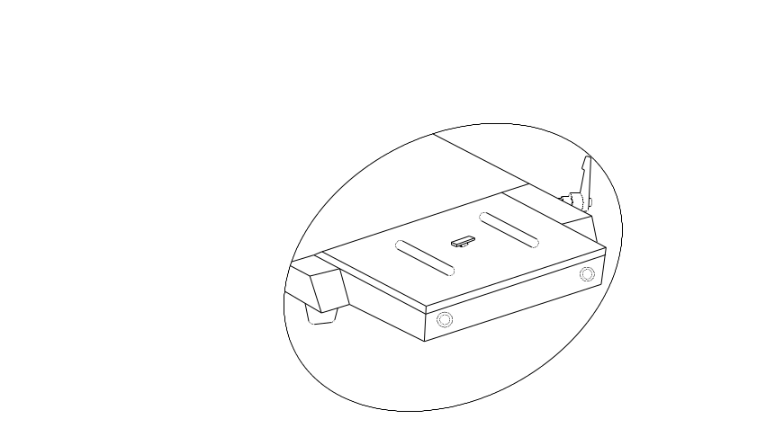
9、Cleaning
Note: Please lock-up the handwheel before cleaning
● Brush off the section scraps with a dry brush.
● Dismantling the knife carriage and its base for cleaning.
Notice: 1) it only can use soft and normal cleanser or soap liquid to clean the instrument!
2) The painting surface of housing cannot resist and bear any acet. and benzene!
3) It is forbidding for any liquid flow into the instrument while cleaning.
10、Maintenance
Routine maintenance
This microtome can be used for a long time without maintenance, however, in order to keep the instrument in the good condition while it is working. we suggest you to get done well with the issues as following:
1. Check out the instrument by the service technician authorized by our company each year at least.
2. When the warranty period is over, you may sign an maintenance contract with the supplier, for the further details, you could contact the after-sell service institute of our company.
3. The instrument should be cleaning up daily.
4. Please do not repair the instrument roughly, otherwise, the commitment of warranty will be ruined. The instrument can only be repaired by the technician authorized by our company .

